|  |  |
| --- | --- |
| **Algorithm** | **Accuracy score** |
| Random Forest | 86 |
| CNN | 89 |
| GaussianNB | 84 |
| AdaBoost Classifier | 89 |
| MLP Classifier | 88 |
| KNN | 88 |

**Note: PCA components set at 10.**

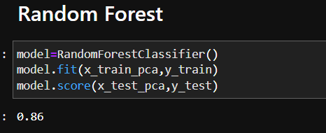

# **CNN**

